BUTLER COUNTY AUDITOR and COMMISSIONER OF ELECTIONS
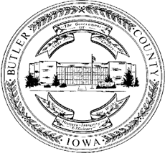

Mary Brouwer, First Deputy
Mindy Pecha, HR/Finance Deputy
Lisa Beadle, Real Estate Deputy

428 6th St, PO Box 325
Allison, IA 50602
Phone: 319-267-2670
Fax: 319-267-4016
E-mail: auditor@butlercoiowa.org

Office of Lizbeth Williams

Phone: 319-267-2670

NOTICE AND CALL OF PUBLIC MEETING
Governmental Body: |  | The Board of Supervisors of Butler County
Date of Meeting: |  | Tuesday, April 21, 2020
Time of Meeting: |  | 9:00 A.M.
Place of Meeting: |  | Telephonic
Telephonic Attendance: Dial-in Number 1-866-951-1151
Conference Room Number: 5432164

The tentative agenda for said meeting is as follows:

1. | 9:00 A.M. | Call to order and review minutes of previous meeting
2. | 9:05 A.M. | Consider adoption of FY21 proposed County Budget
3. | 9:15 A.M. | Review office staffing
 |  | Time for public comment
 |  | Review claims
This Notice is given at the direction of the Chairman, pursuant to Chapter 21, Code of Iowa, and the local rules of said governmental body.

Lizbeth Williams
Secretary to the Butler County Board of Supervisors

